# Lesson 9.0

Display: inline-block set the block to be

inline on the same row as long there is enough space

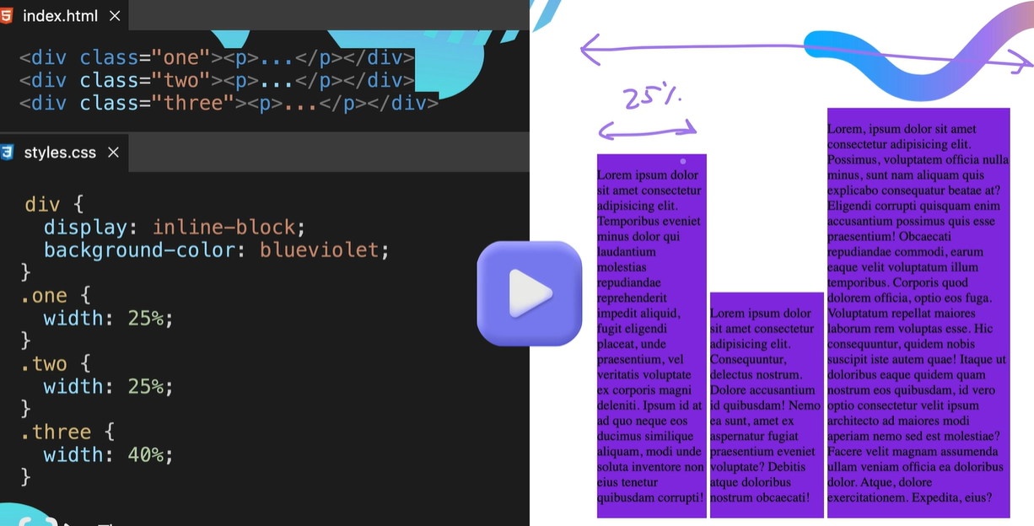

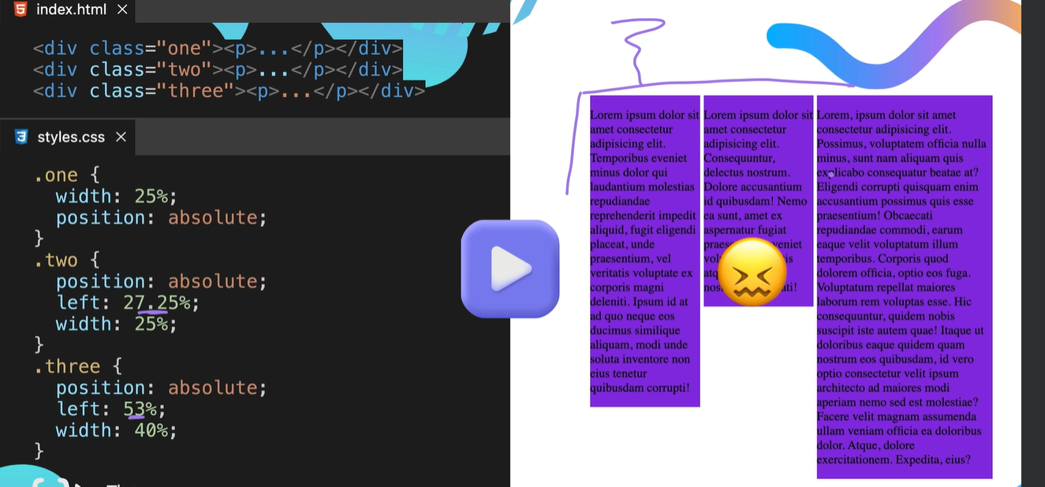

Could use positions: absolute to overlay the normal html flow see above but its complex

Could use float

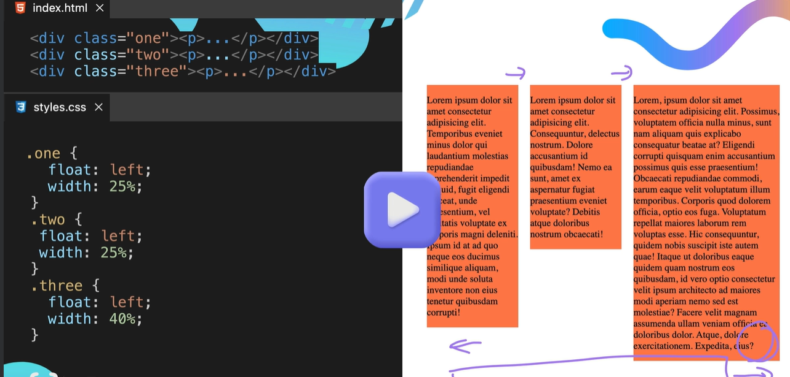

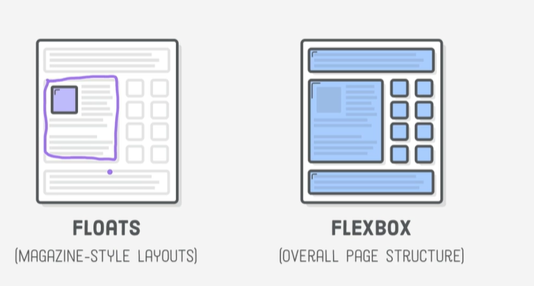

# CSS Flexbox

Normal html flow

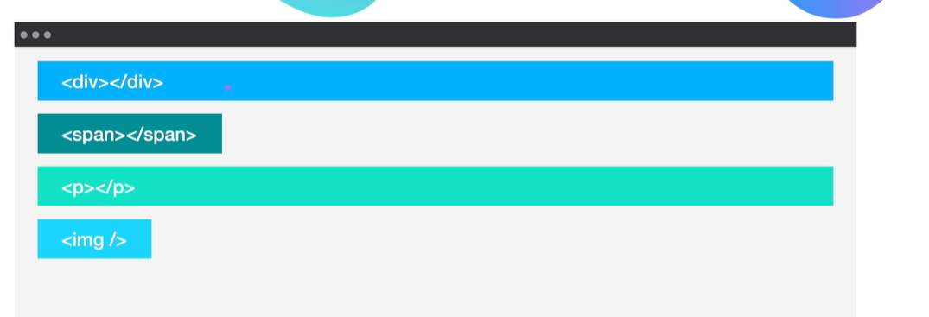

Display is usually based on content with in the box

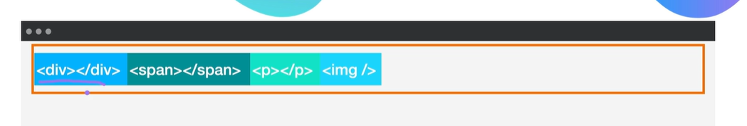

Can use display: inline-flex

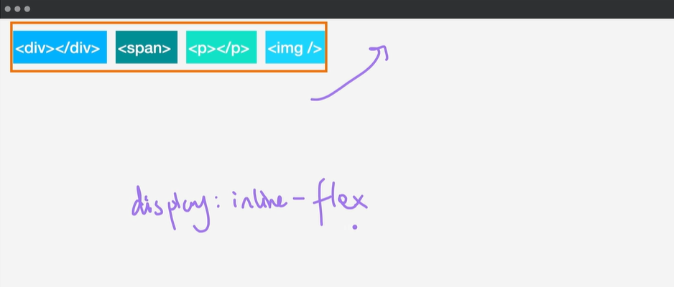

Using display: flex and gap

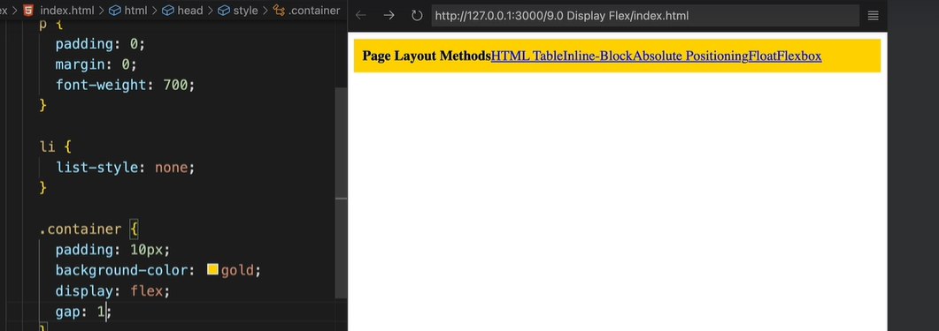

Flex-direction

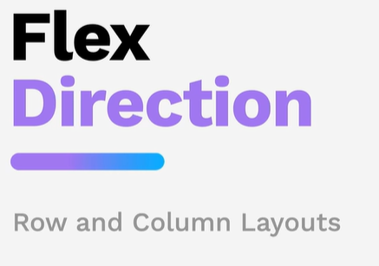

Default flow

Inline and block

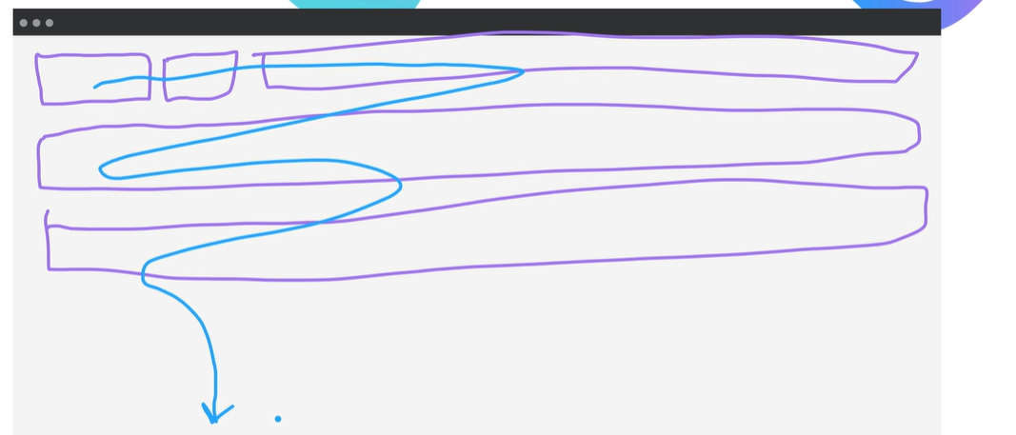

Flex box

Pushes all the content in to a row

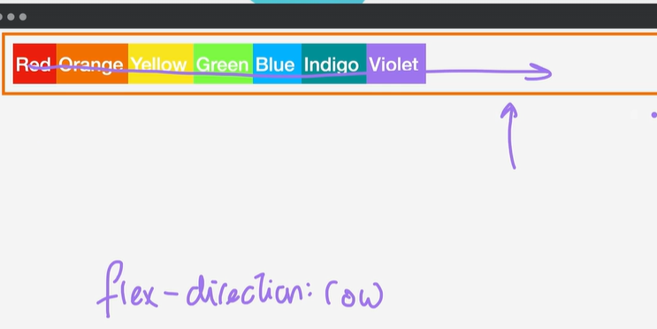

This is the main axis left to right cross axis

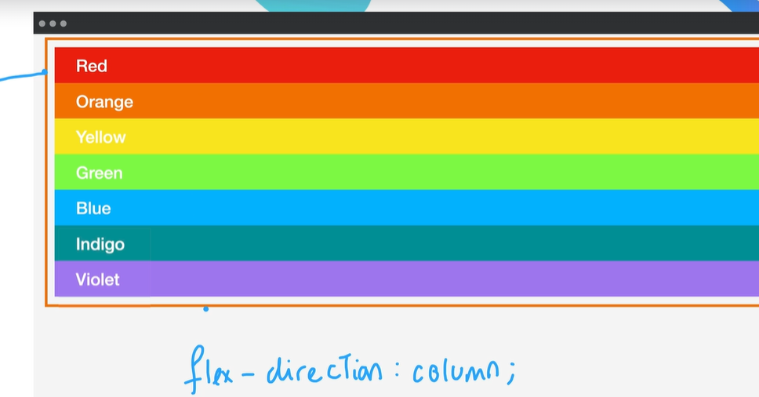



Will expand the main axis the flex-basis is contained on the element not the container

Is applied to the child not the container – see below

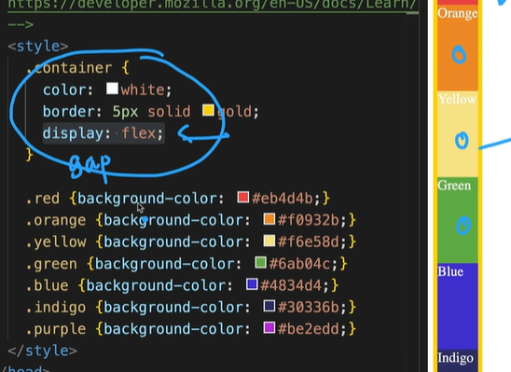

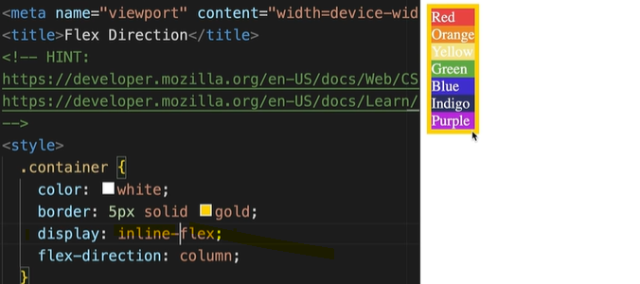

Change to inline-flex

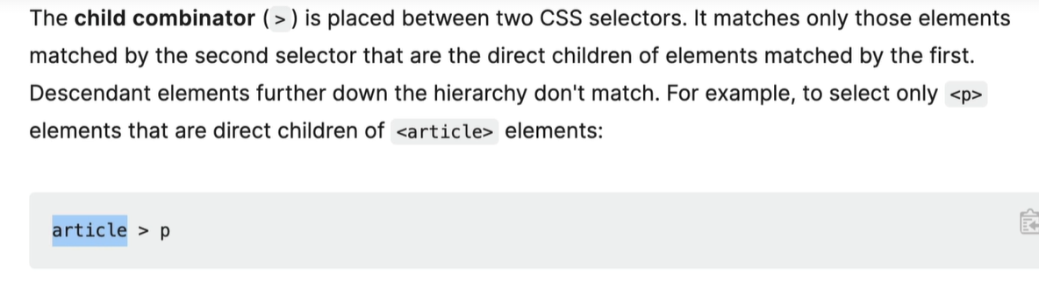

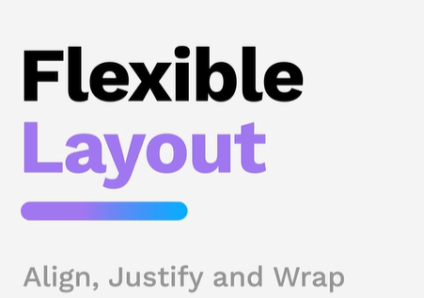

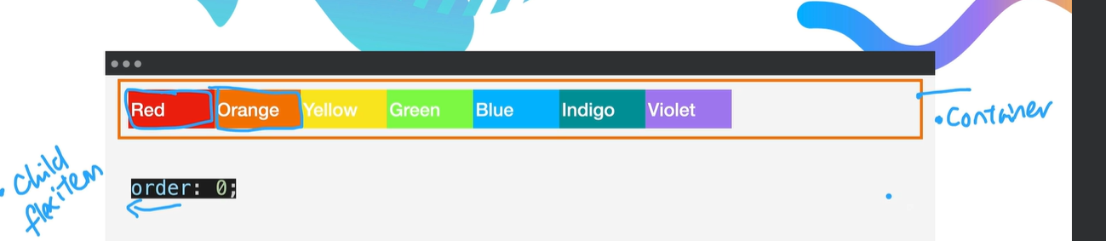

Default for flex is nowrap

Flex-wrap: nowrap

Flex-wrap: wrap

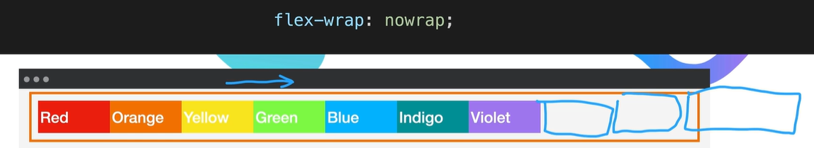

This is set on the container not the item

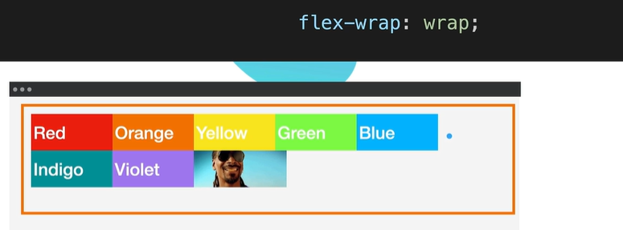

Justify-content:

This is set on the container

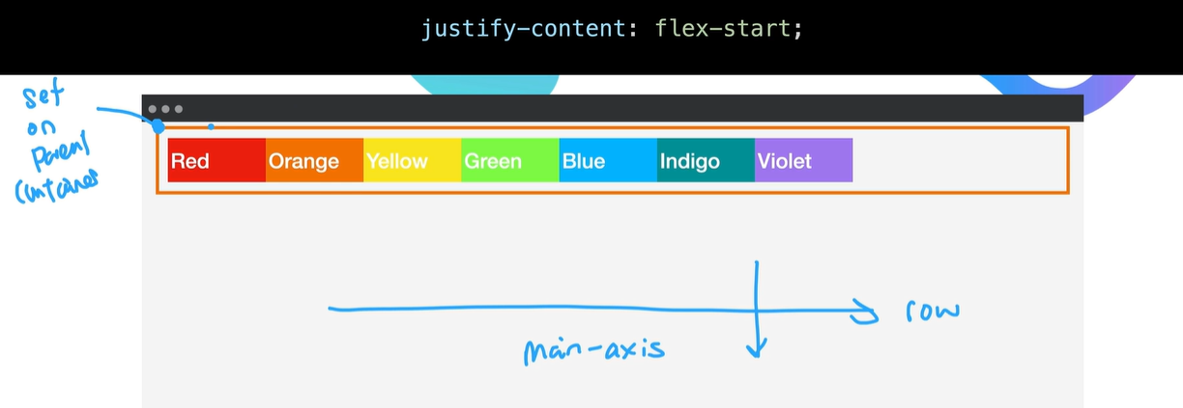

Align-items

Set on the container

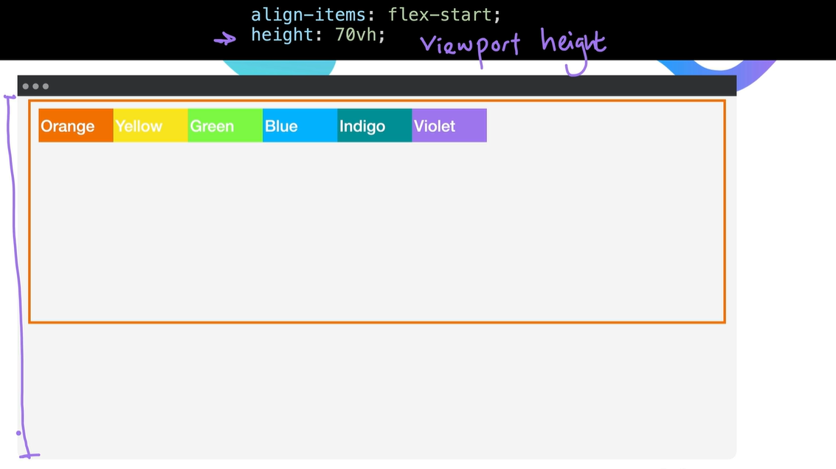

Align-self is

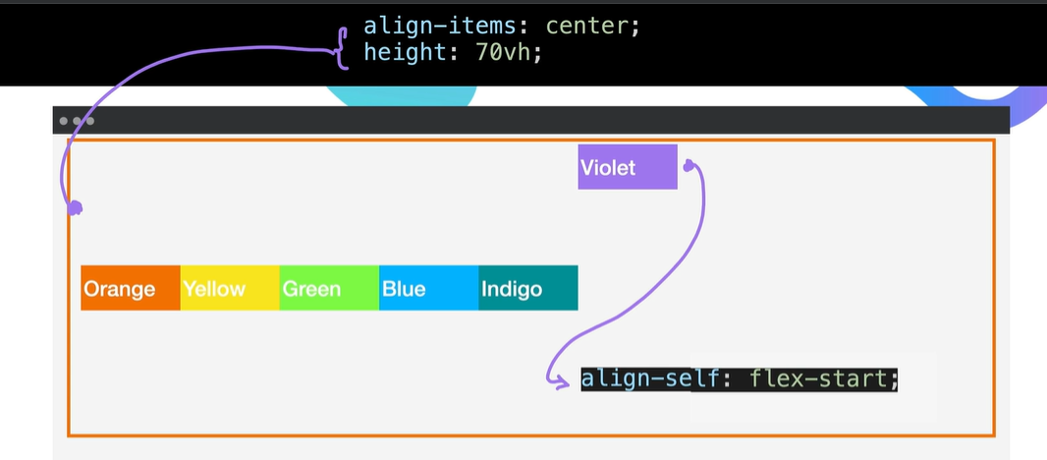

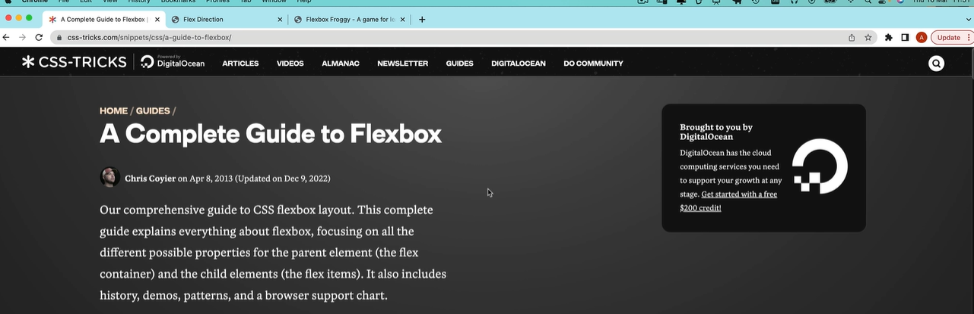

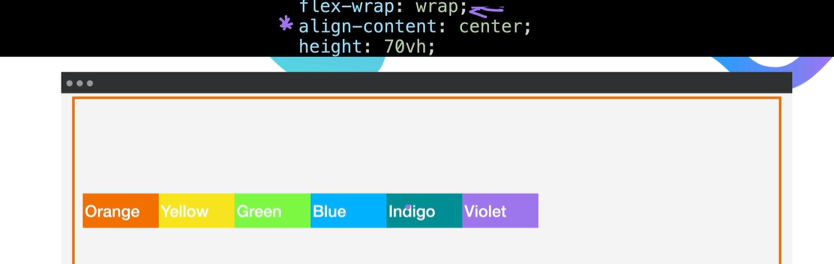

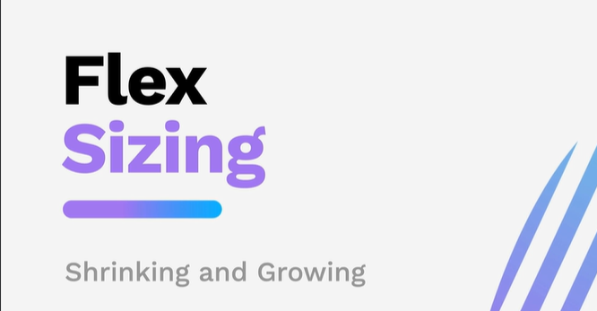

Priority list

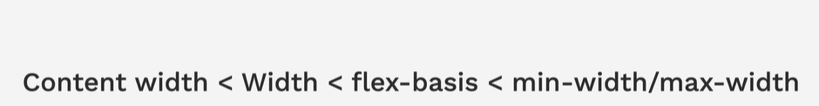

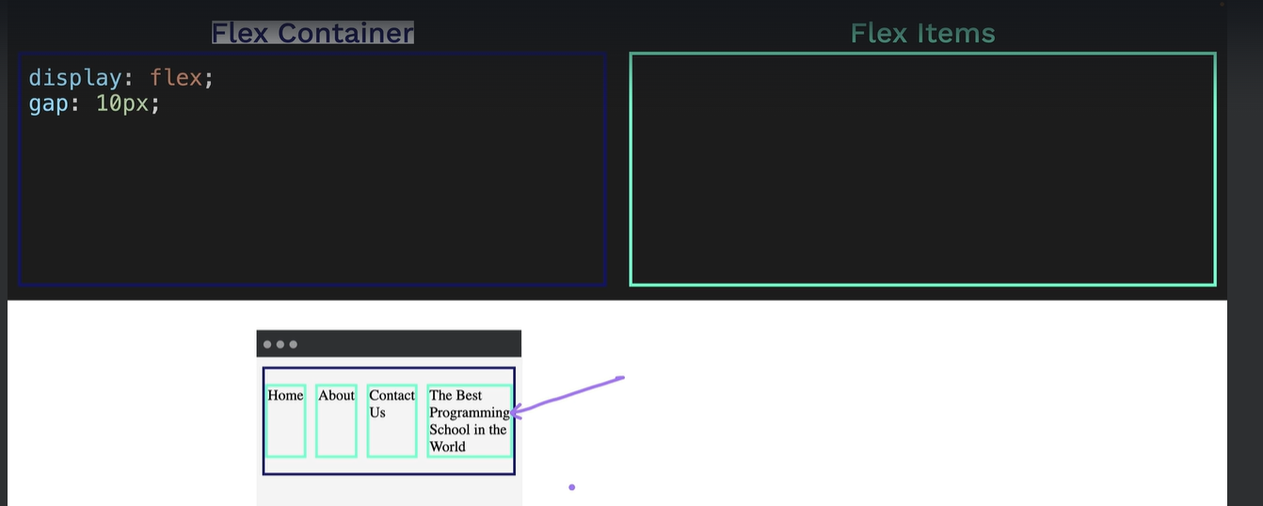

Respect the 1oopx width setting

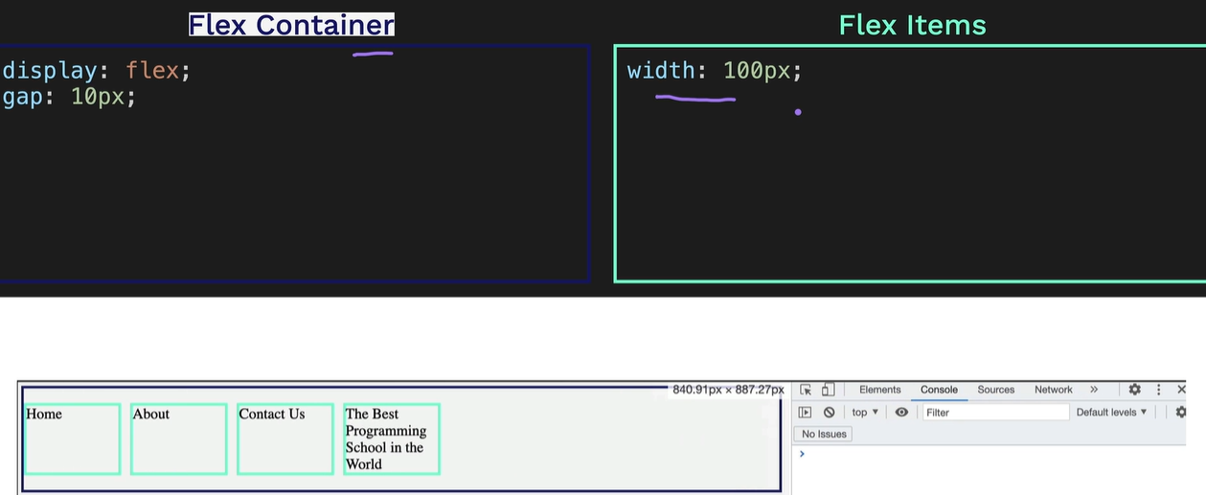

Flex-basis wins

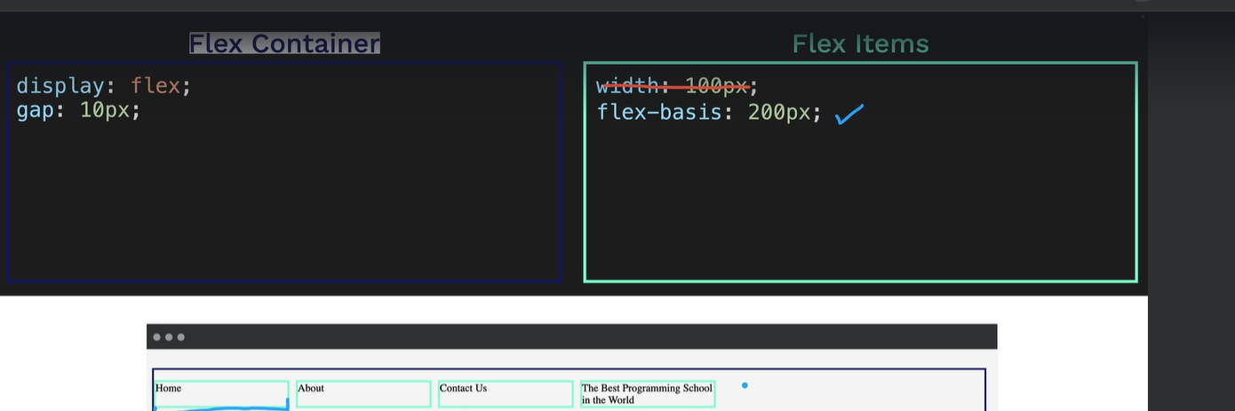

Max-width: will win in this scenario

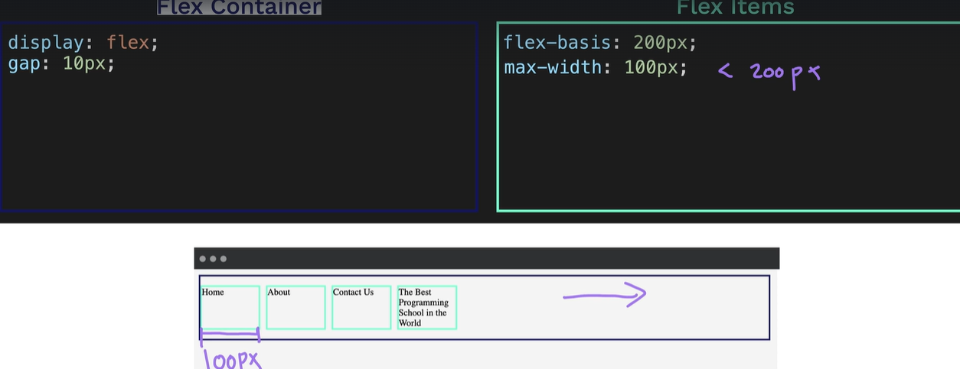

Unless the flex-basis is smaller then flex-basis will apply

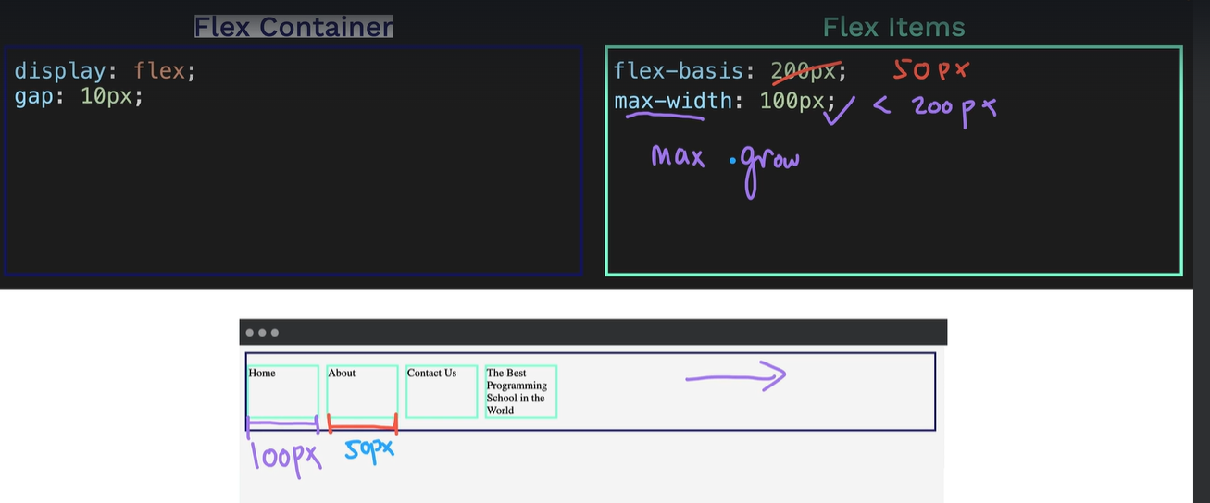

Min-width: wins but when resizing the screen the items will not be displayed best the minumn size

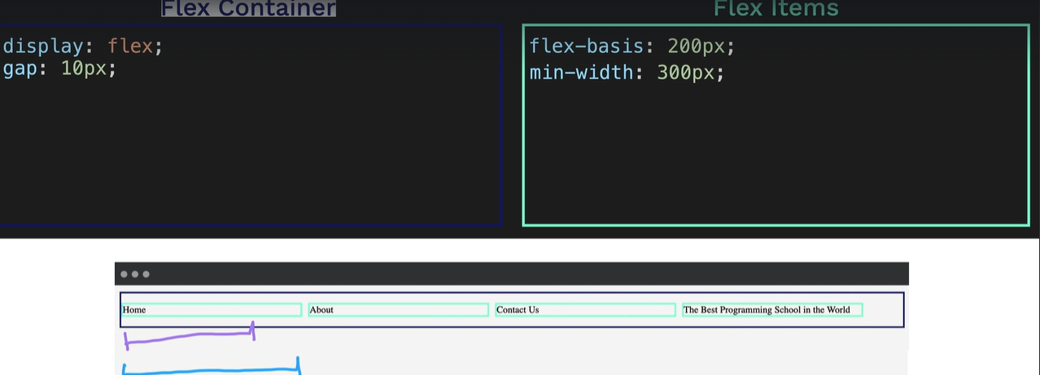

Flex-shrink and flex-grow to 0

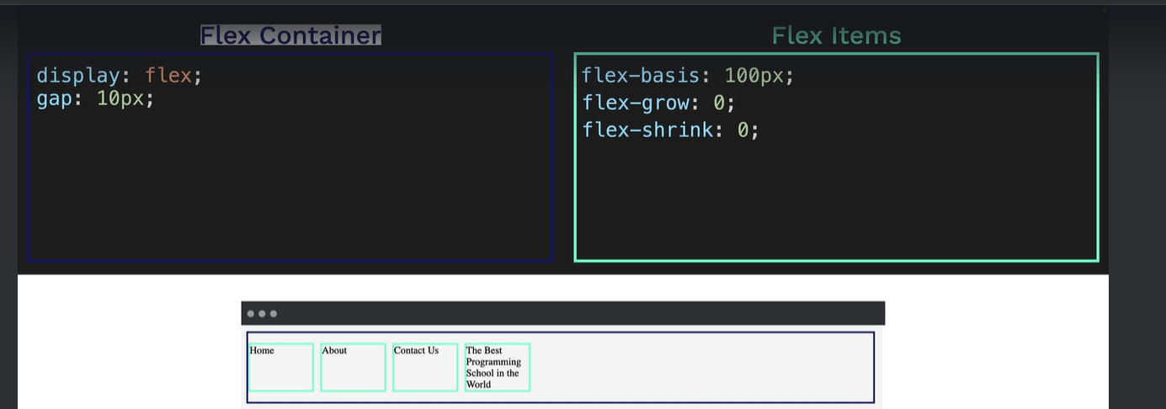

Flex-basis is the initial starting value

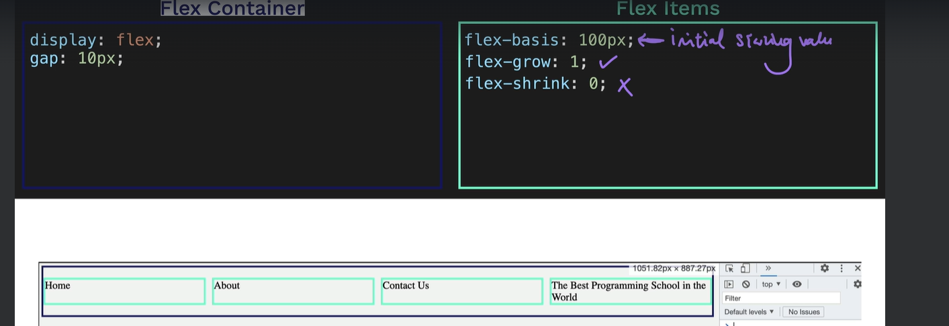

Grow is on show the items will grow

This is the default behaviour

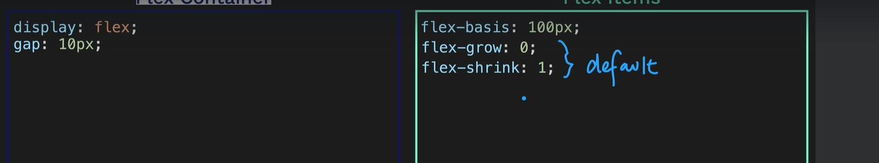

Short hand flex: 1 1 0

Grow – shrink - basis

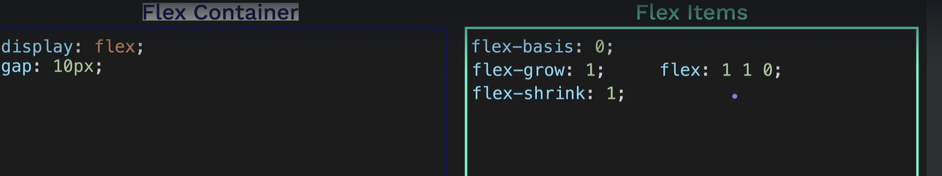

You can even use flex: 1 to use the above

You can use flex: 1 flex: 2 and flex: 3 the get the below

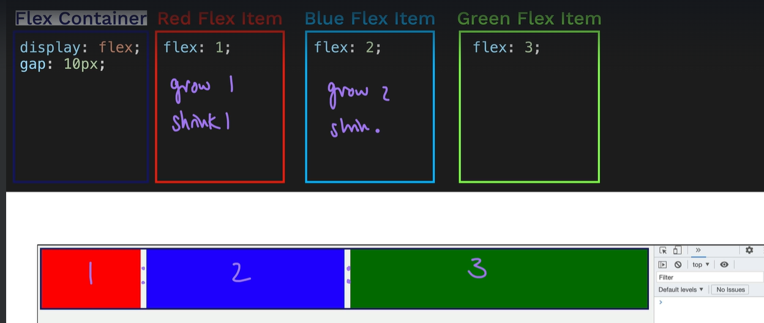

You can set a media query and change the flex-direction from row to column when the screen hits a certain size

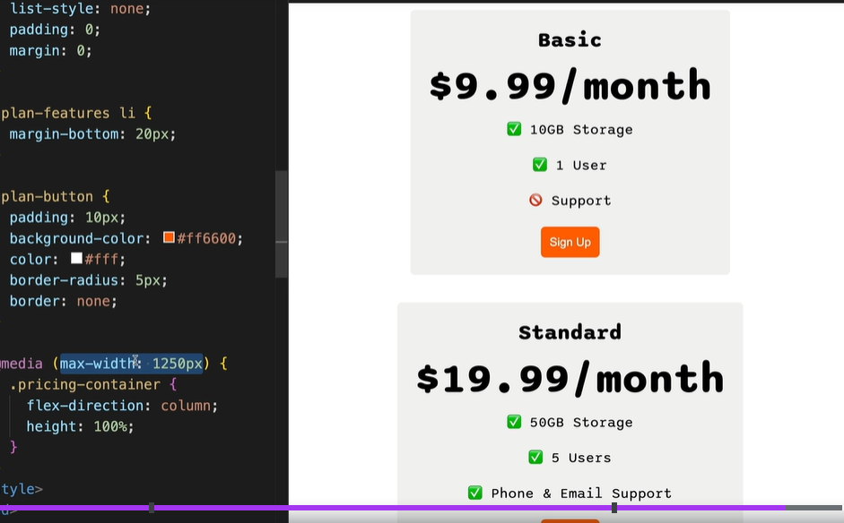

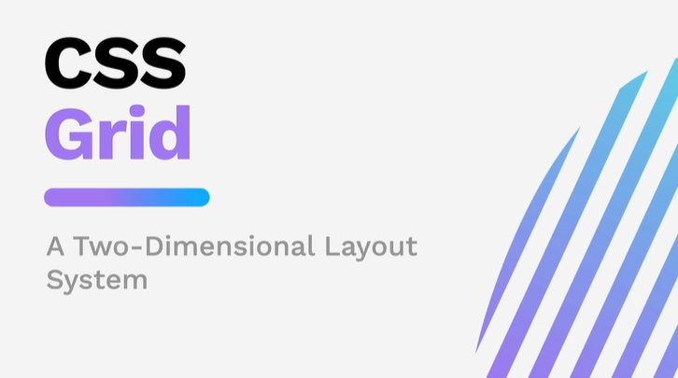

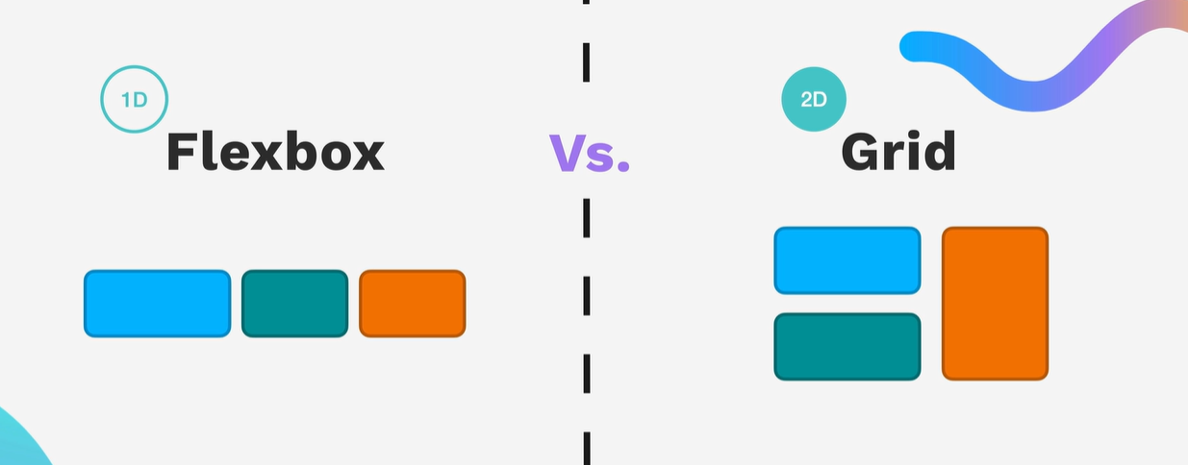

Code to create a grid

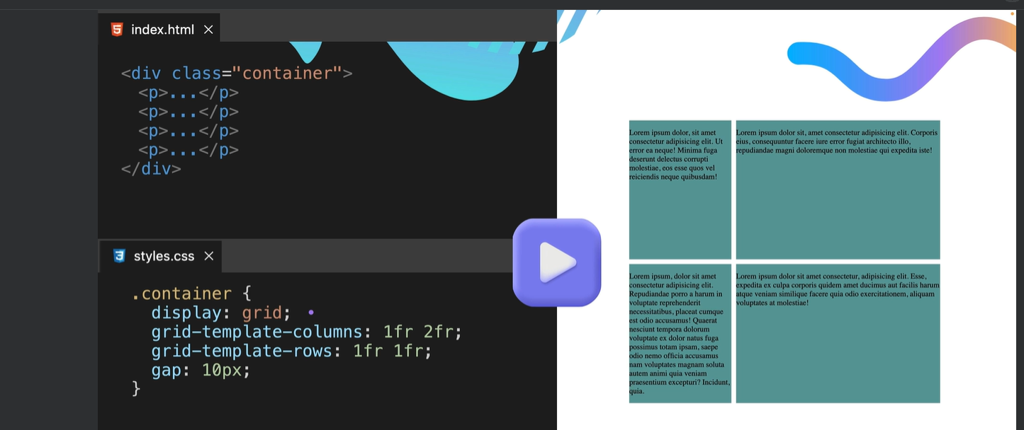container information

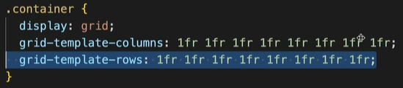

Item information

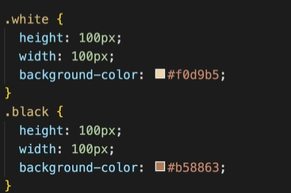

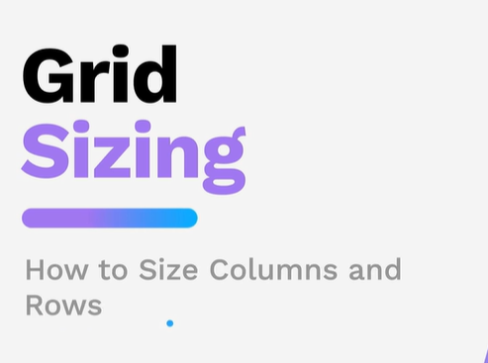

Fixed columns

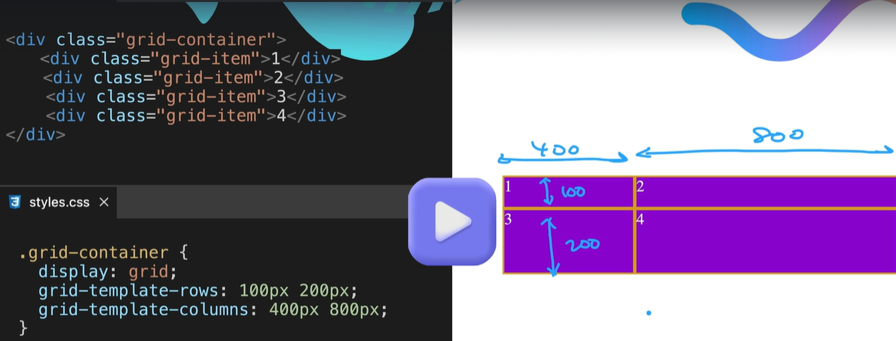

fixed

Fixed size columns and rows are not responsive

This is shorthand for columns and rows gride-template:

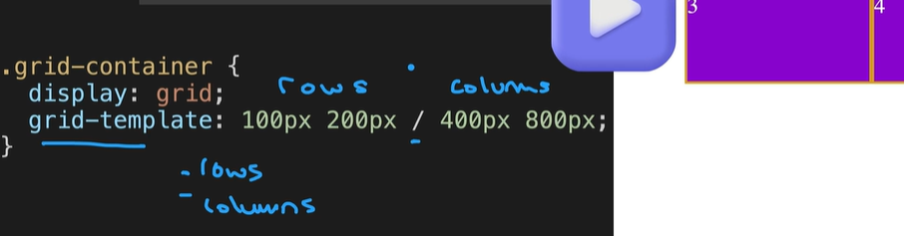

Auto

Auto introduces a little more responsive to the last column and row

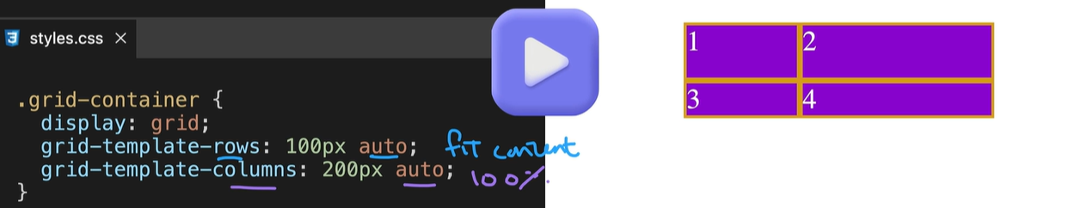

The vertical row will only be as big as the content that fits in the item

Fractional defines the ratios fr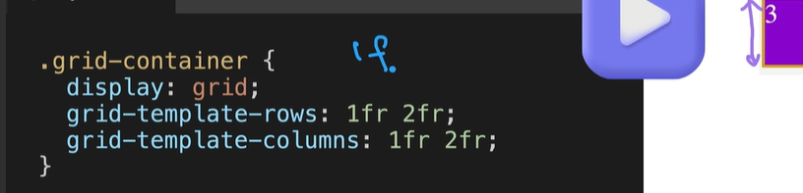

It will grow and maintain the fractions size on the horizontal but it will fit the content on the vertical axis

Minmax

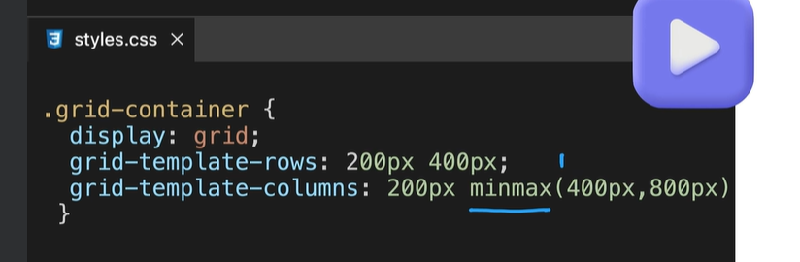

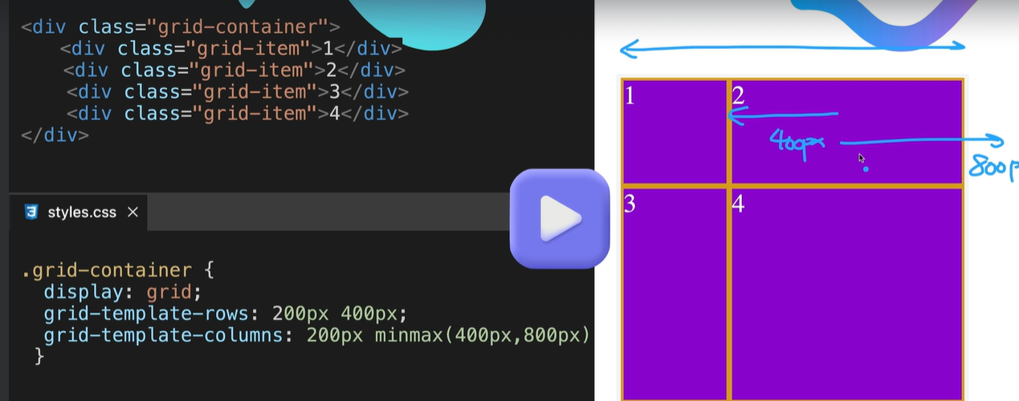

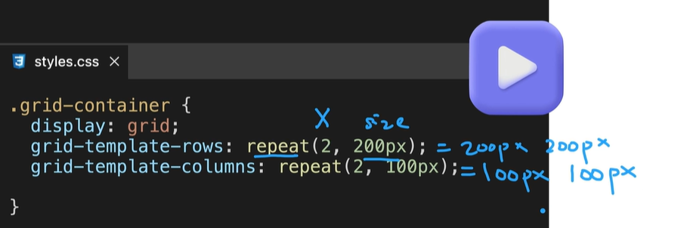

Less items than grids

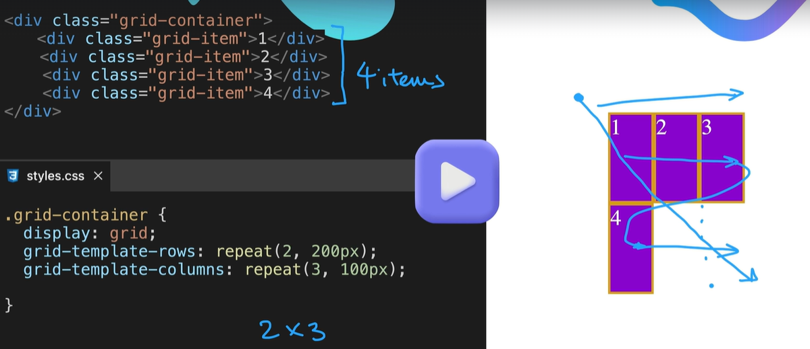

More divs than columns and rows

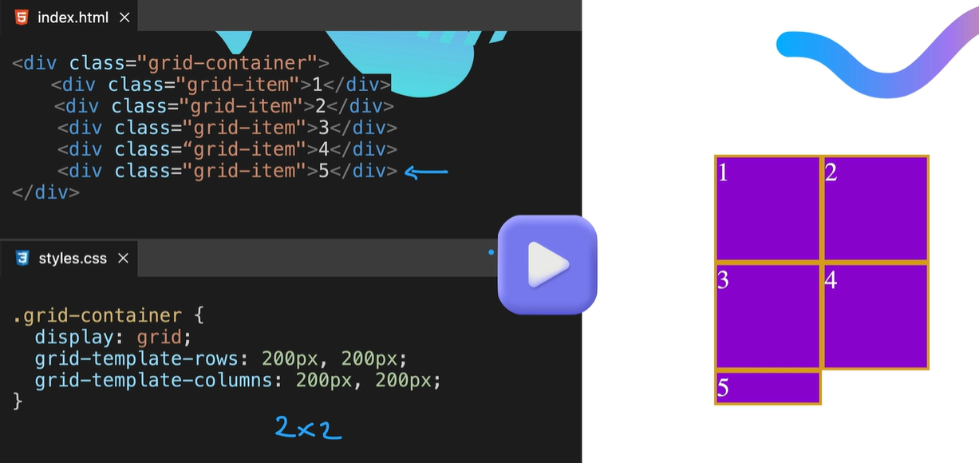

Will get the same column width and contain height

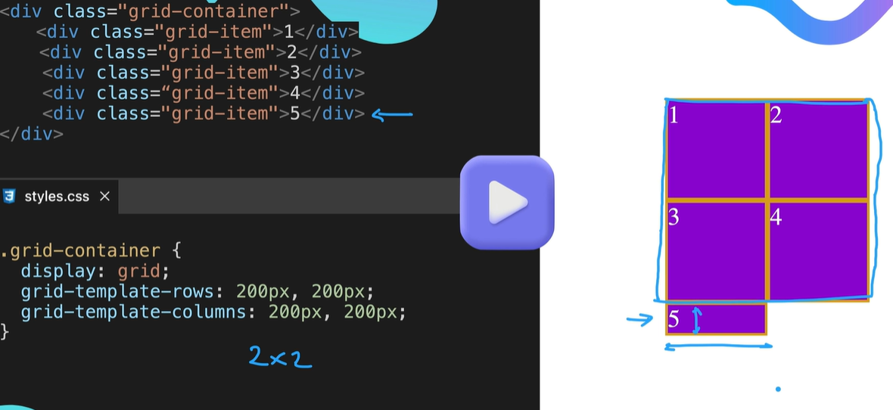

Grid-auto-rows: 300px; this means any rows added will get a 300px height row

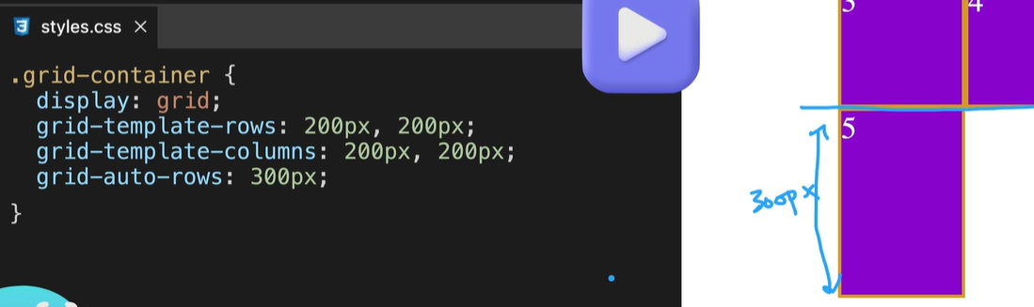

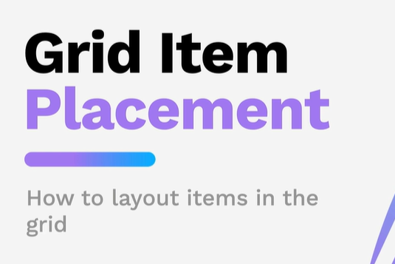

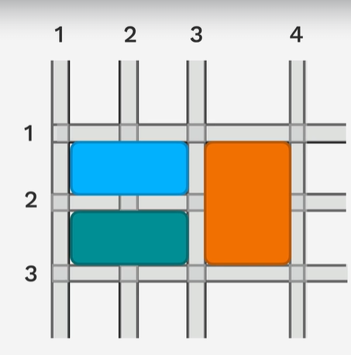

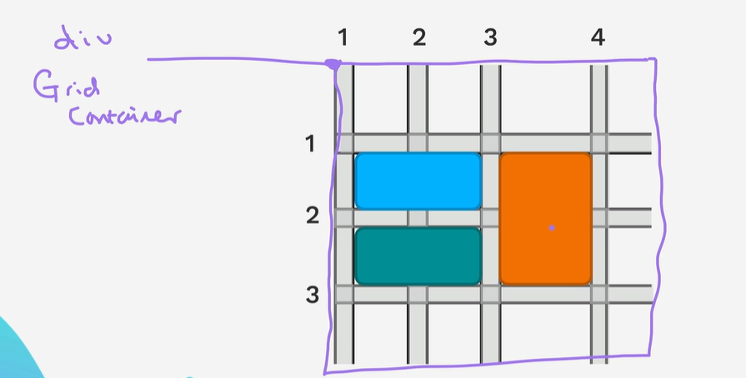

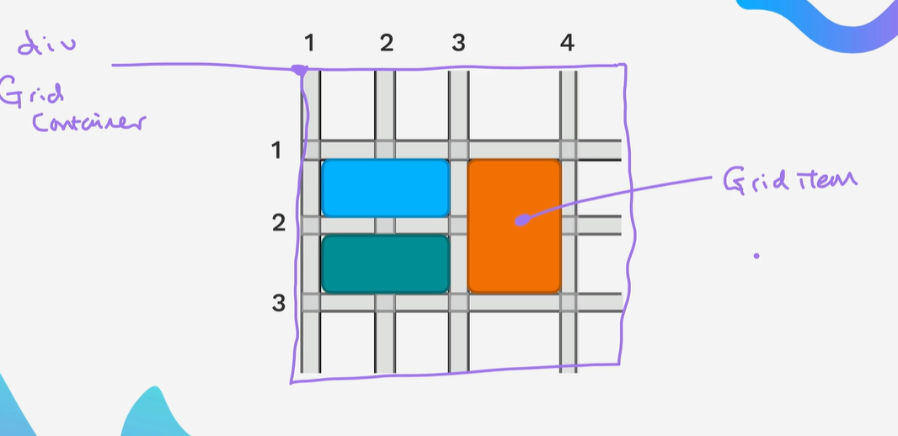

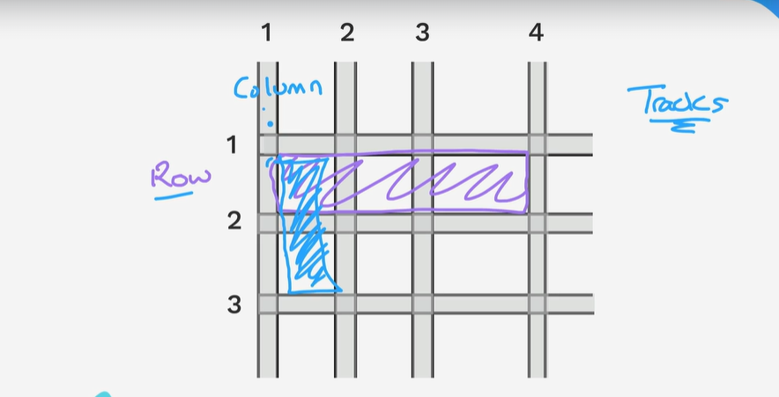

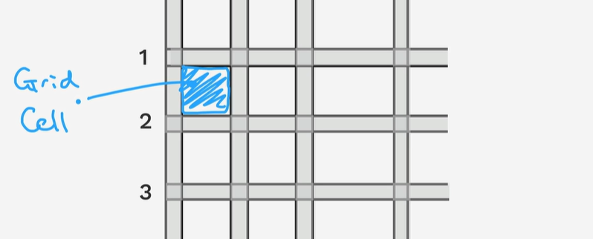

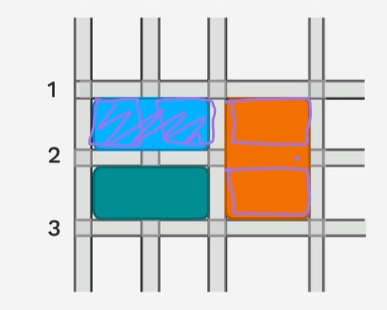

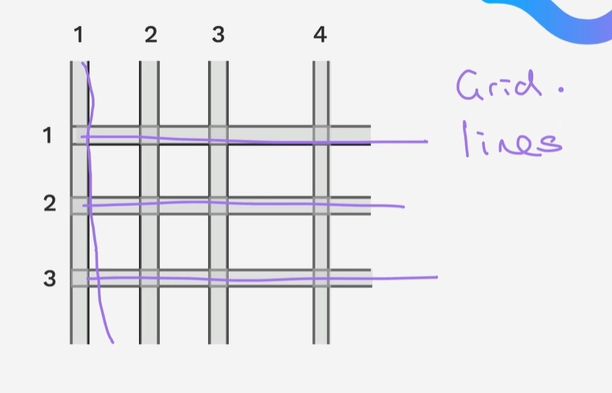

Gap property

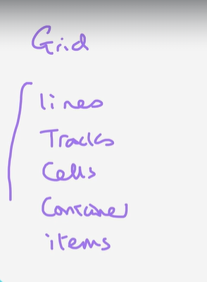

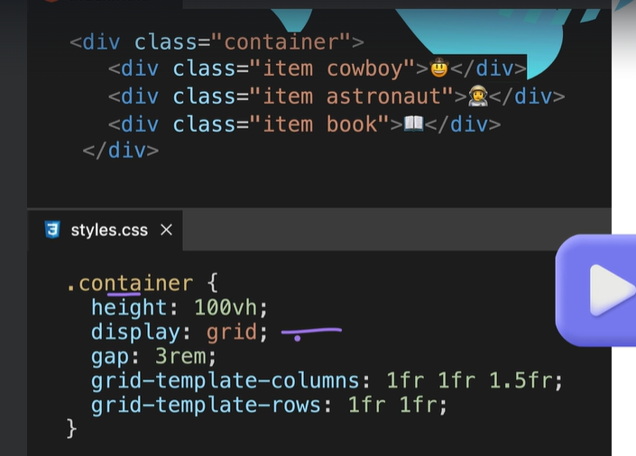

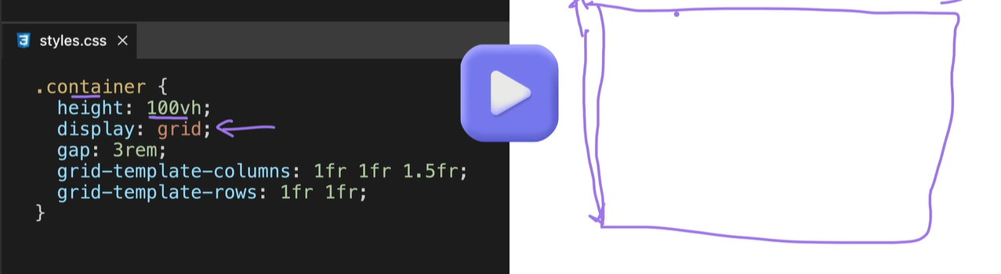

Using height: 100vh 100 viewport will stretch the container down to the bottom of the screen

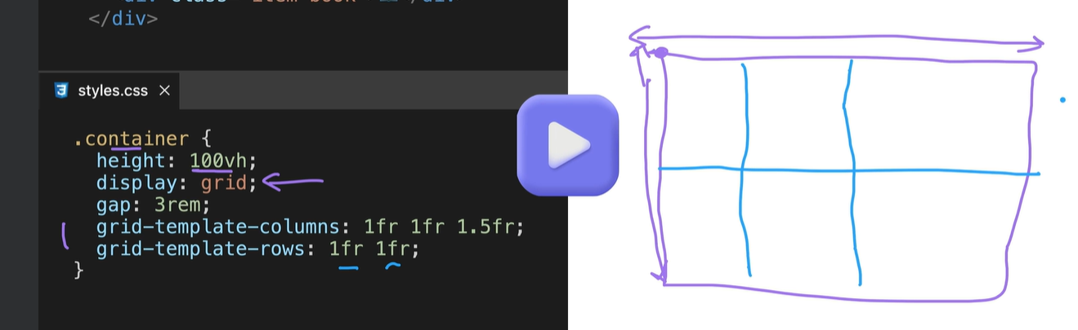

This is the default position cowboy – astronaut - book

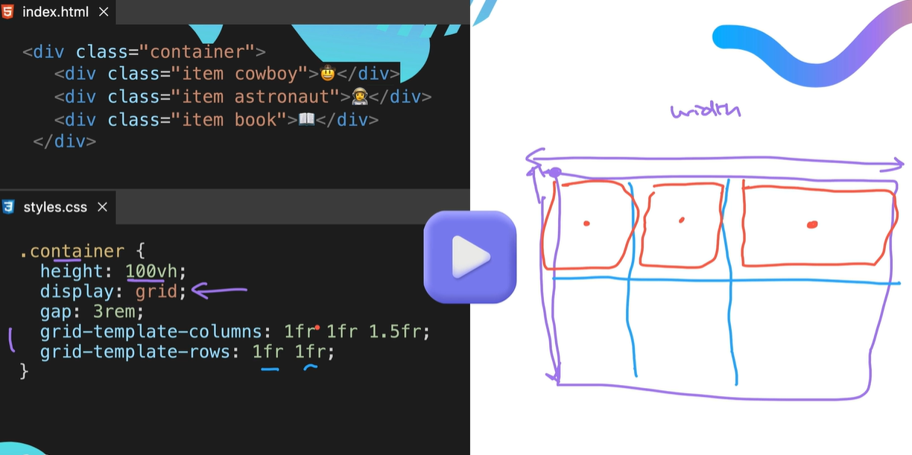

Using a gap: 3rem

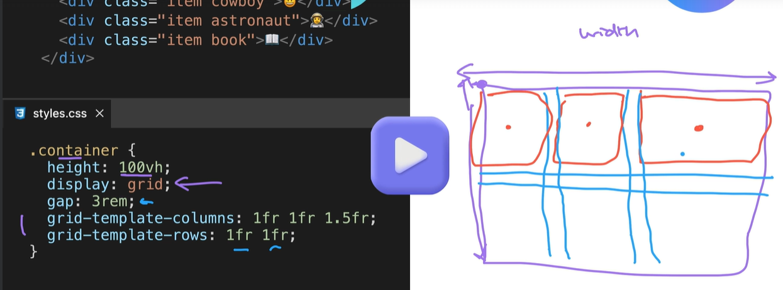

Using flexbox with grid

We can centre the items by using css code .item {

Display: flex;

Justify-content: centre - this will justify the image at the top of the screen in the center

Align-items: centre - this will align the items in the centre of the div

}

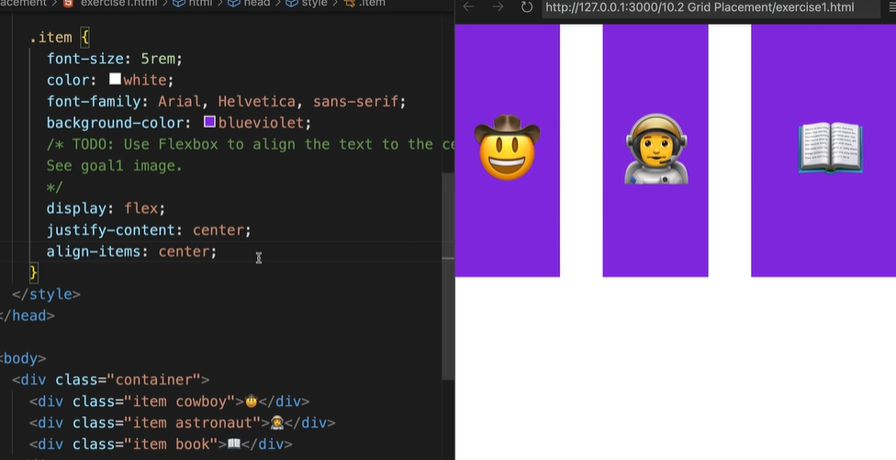

Create this layout in grid

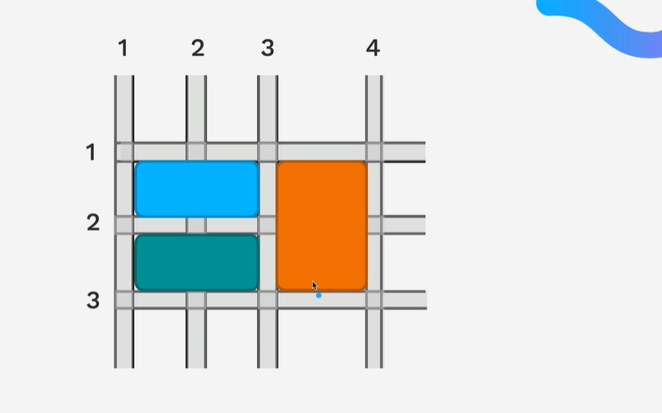

Cowboy item add the line in

grid-column: span 2;

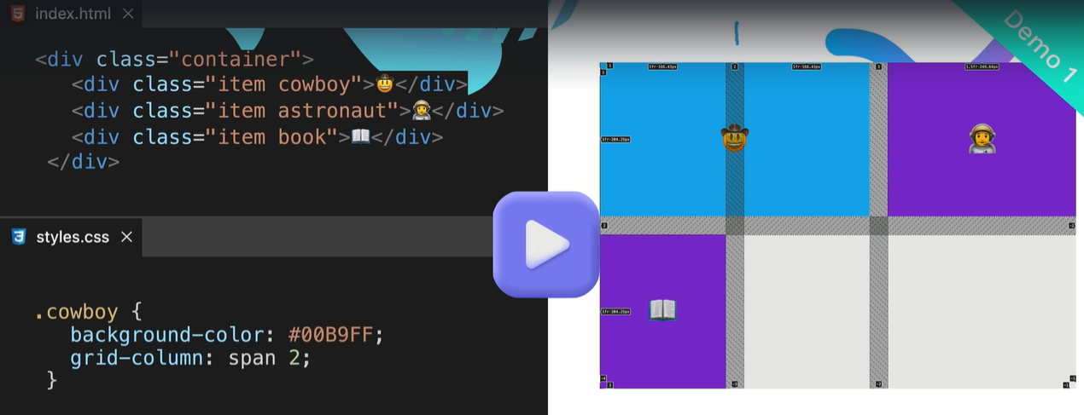

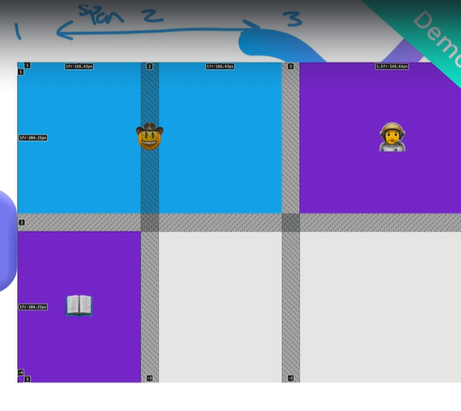

grid-column: span 2; is short hand for

grid-column-start: span 2

grid-column-end: auto;

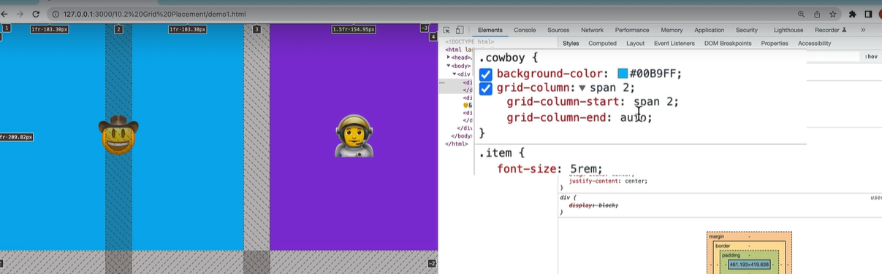

You can use a negative value

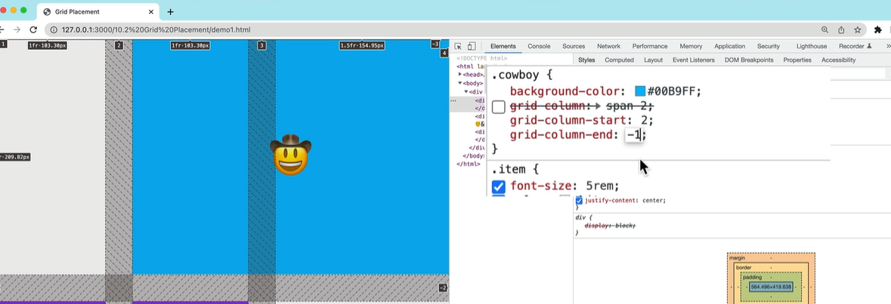

Grid-column is short for grid-column-start and grid-column-end

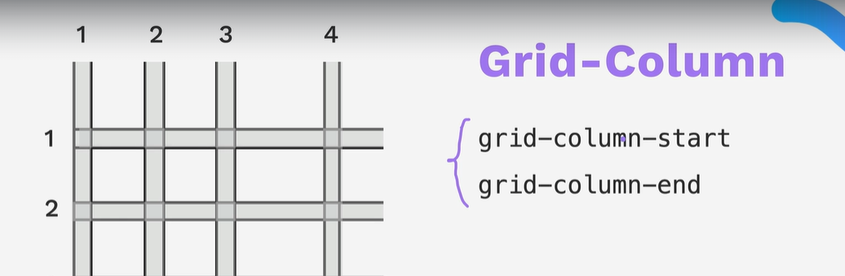

Grid-column: span x

Means startt where you are meant to start and span two columns

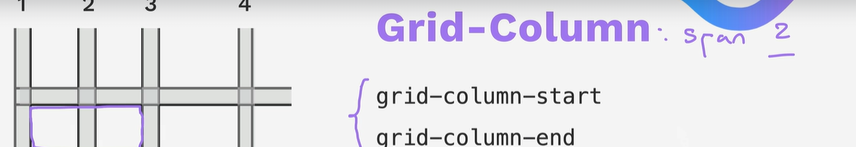

Also grid-row

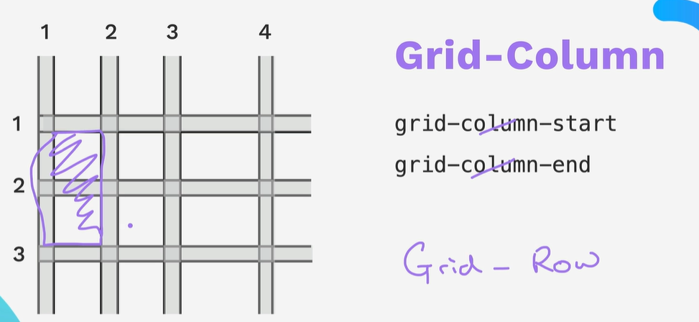

Order can change the order of the divs then span the column

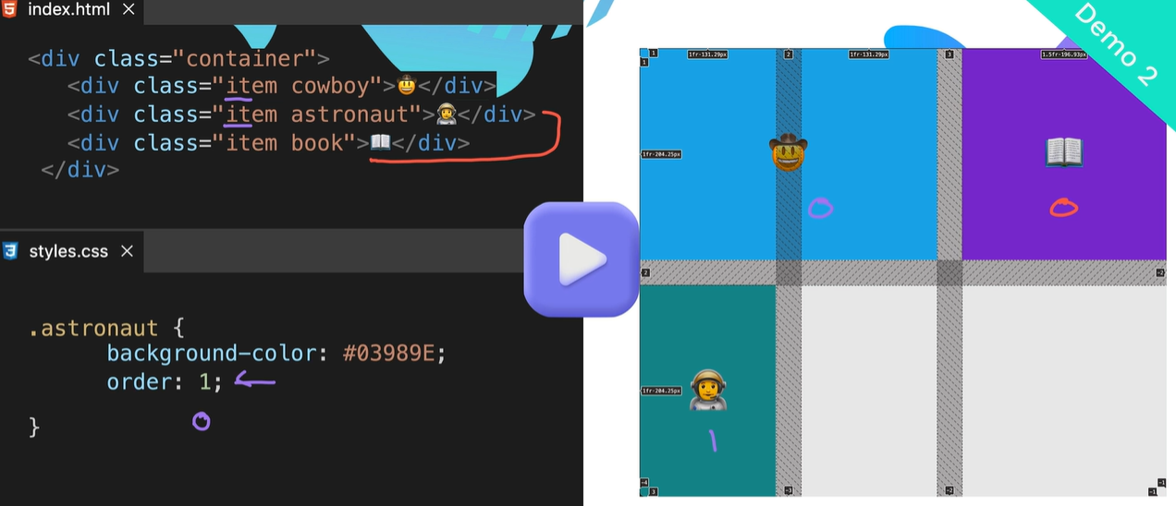

You can also do this 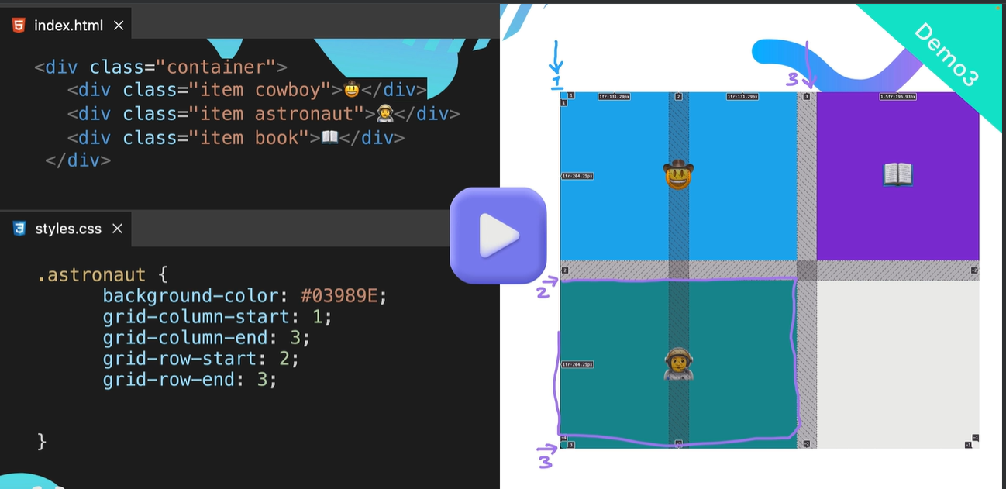

You can use the following short hand for the grid locations

Grid-area: 2 / 1 /3 /3 - see above if you are going to use area you should use it for all the items

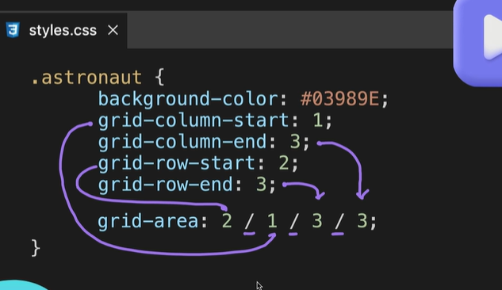

You can also overlay a grid cell on top of another grid cell

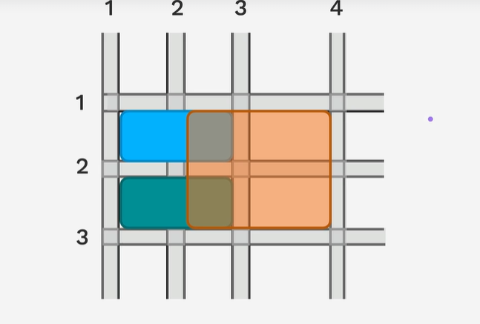

First 6 characters are the colours and the last 2 are for transparency

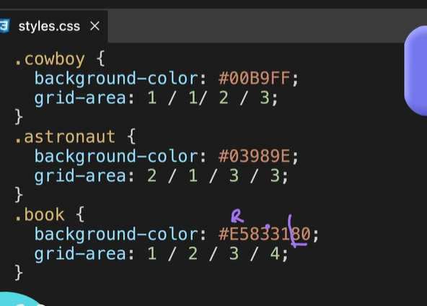

Grid-row-start -grid column-start grid-row-end – grid-column-end

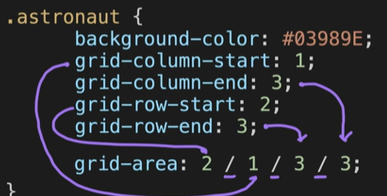

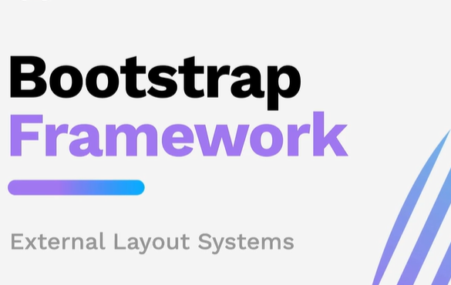

12 column layout

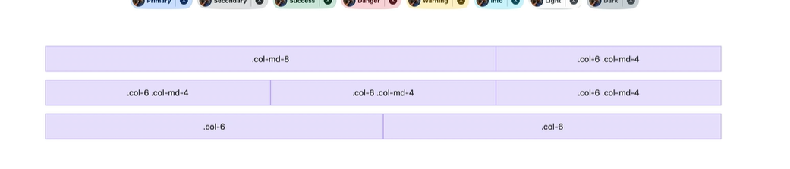

Adding in the links to get bootstrap

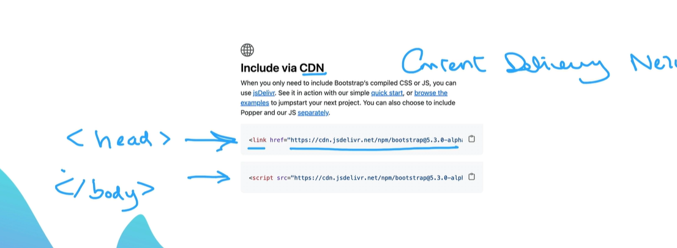

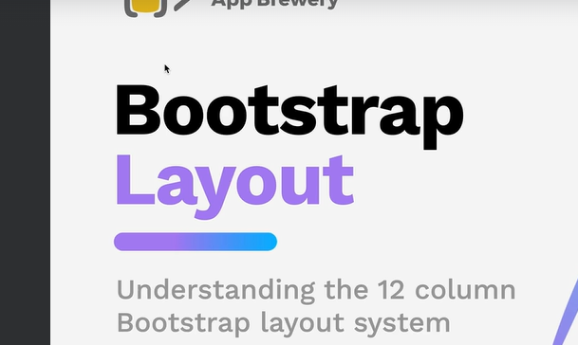

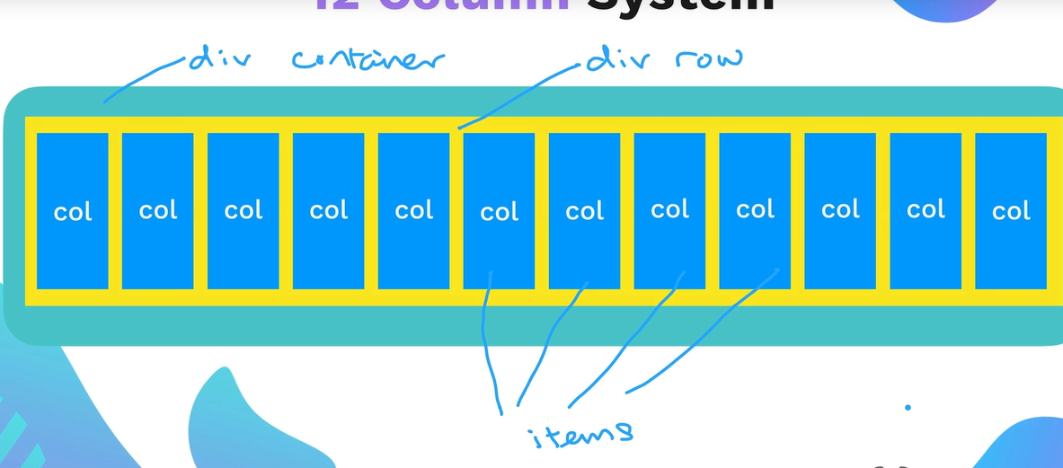

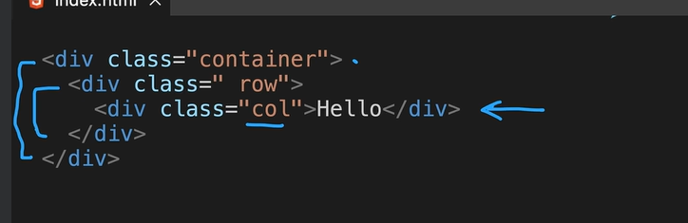

Break points - only the width of the viewport

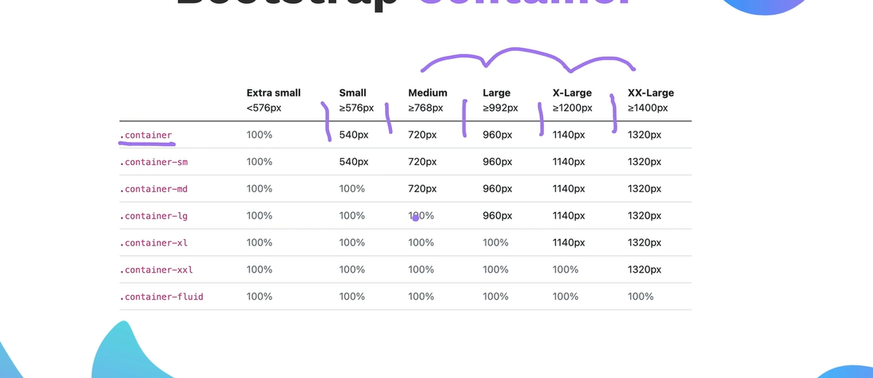

Using the class col-2 col-6 etc

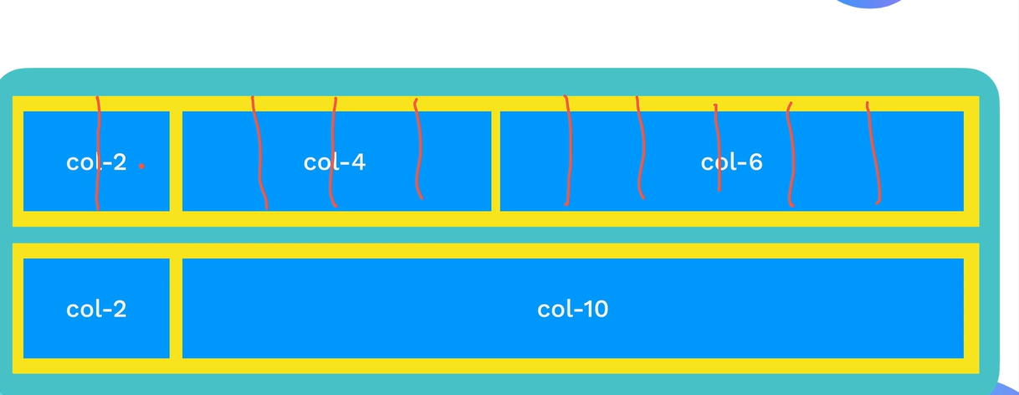

Code for a row that has 3 columns

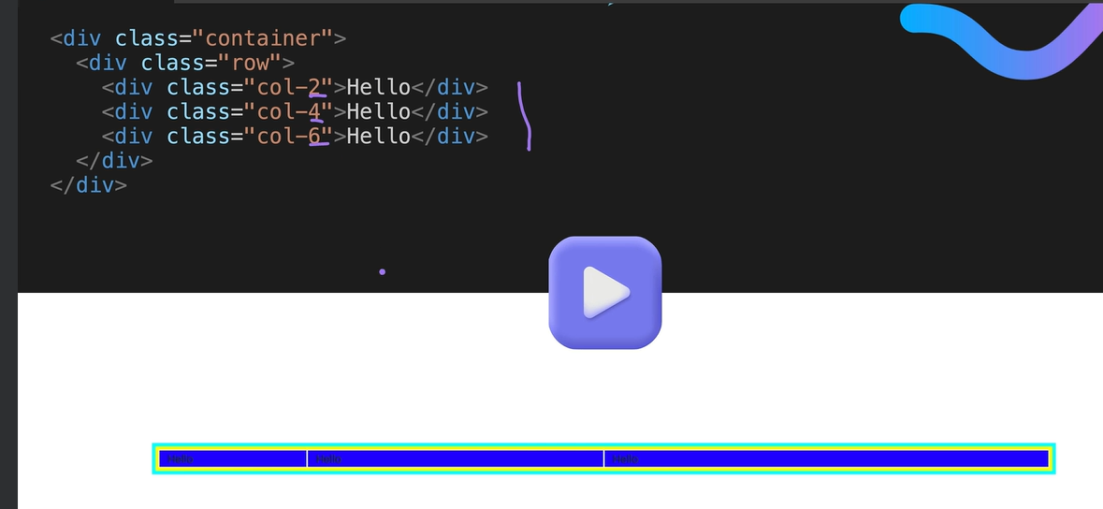

No eed for media queries

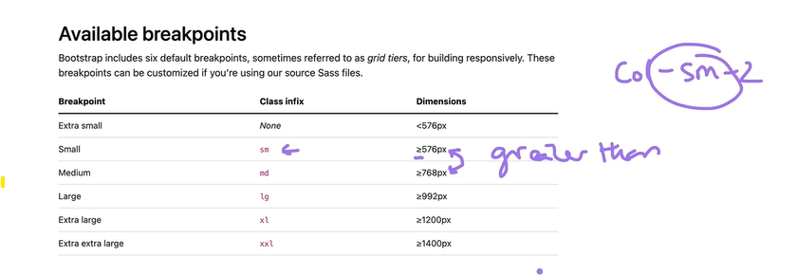

Thes break point are on the items

Col-sm-2 col-sm-4 etc

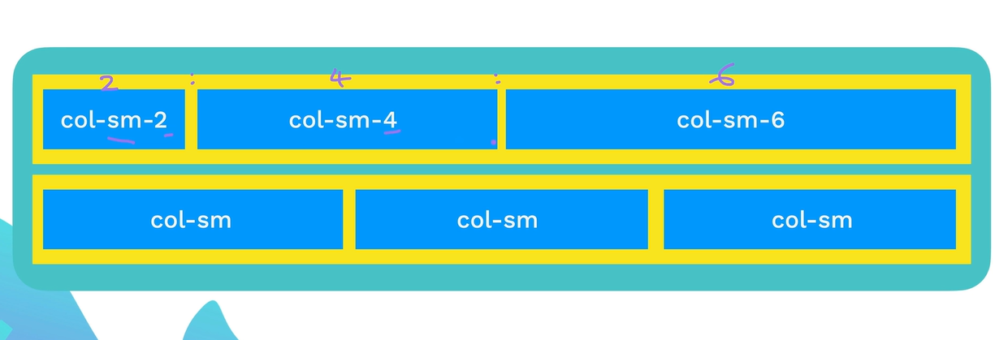

A single div can have multiple break point

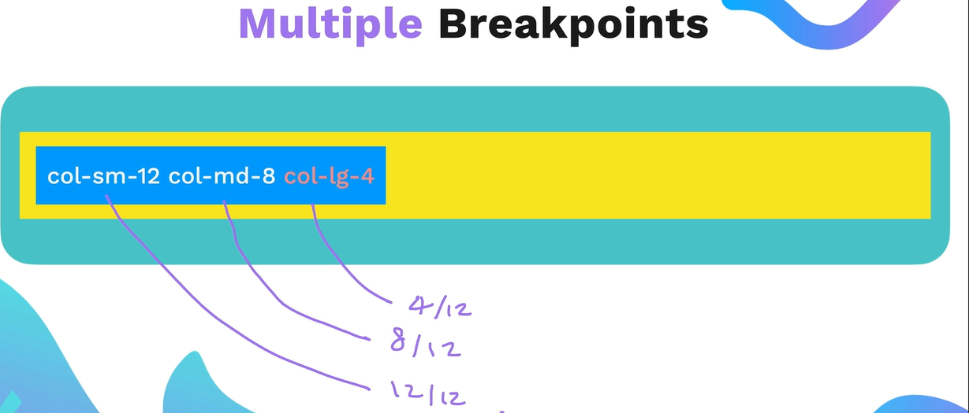

You can mix and match see below as col without a number mean auto

